EF Core 8.0 Guided Hands-On Exercises

Exercise 1 : Understanding ORM with a Retail Inventory System

CODE:

using Microsoft.EntityFrameworkCore;

using System;

using System.Collections.Generic;

using System.Linq;

#region Models

public class ProductCategory

{

    public int ProductCategoryId { get; set; }

    public string Title { get; set; } = "";

    public List<InventoryItem> Items { get; set; } = new();

}

public class InventoryItem

{

    public int InventoryItemId { get; set; }

    public string Name { get; set; } = "";

    public string CategoryLabel { get; set; } = "";

}

#endregion

#region Database Context

public class ShopInventoryContext : DbContext

{

    public DbSet<ProductCategory> ProductCategories => Set<ProductCategory>();

    public DbSet<InventoryItem> InventoryItems => Set<InventoryItem>();

    protected override void OnConfiguring(DbContextOptionsBuilder configBuilder)

    {

        // Using SQLite to store inventory data in a local file

        configBuilder.UseSqlite("Data Source=SmartStoreInventory.db");

    }

}

#endregion

#region App Entry Point

public class StoreInventoryConsoleApp

{

    public static void Main()

    {

        using var dbContext = new ShopInventoryContext();

        dbContext.Database.EnsureCreated(); // Creates the SQLite database if not present

        // Seed data only if database is empty

        if (!dbContext.ProductCategories.Any())

        {

            var gadgetsCategory = new ProductCategory { Title = "Gadgets" };

            dbContext.ProductCategories.Add(gadgetsCategory);

            dbContext.InventoryItems.AddRange(

                new InventoryItem { Name = "Smartphone", CategoryLabel = "Gadgets" },

                new InventoryItem { Name = "Wireless Earbuds", CategoryLabel = "Gadgets" }

            );

            dbContext.SaveChanges();

        }

        // Display current inventory

        Console.WriteLine("Inventory List:");

        foreach (var item in dbContext.InventoryItems)

        {

            Console.WriteLine($"- {item.Name} [{item.CategoryLabel}]");

        }

    }

}

#endregion

OUTPUT:

Inventory List:

- Smartphone [Gadgets]

- Wireless Earbuds [Gadgets]

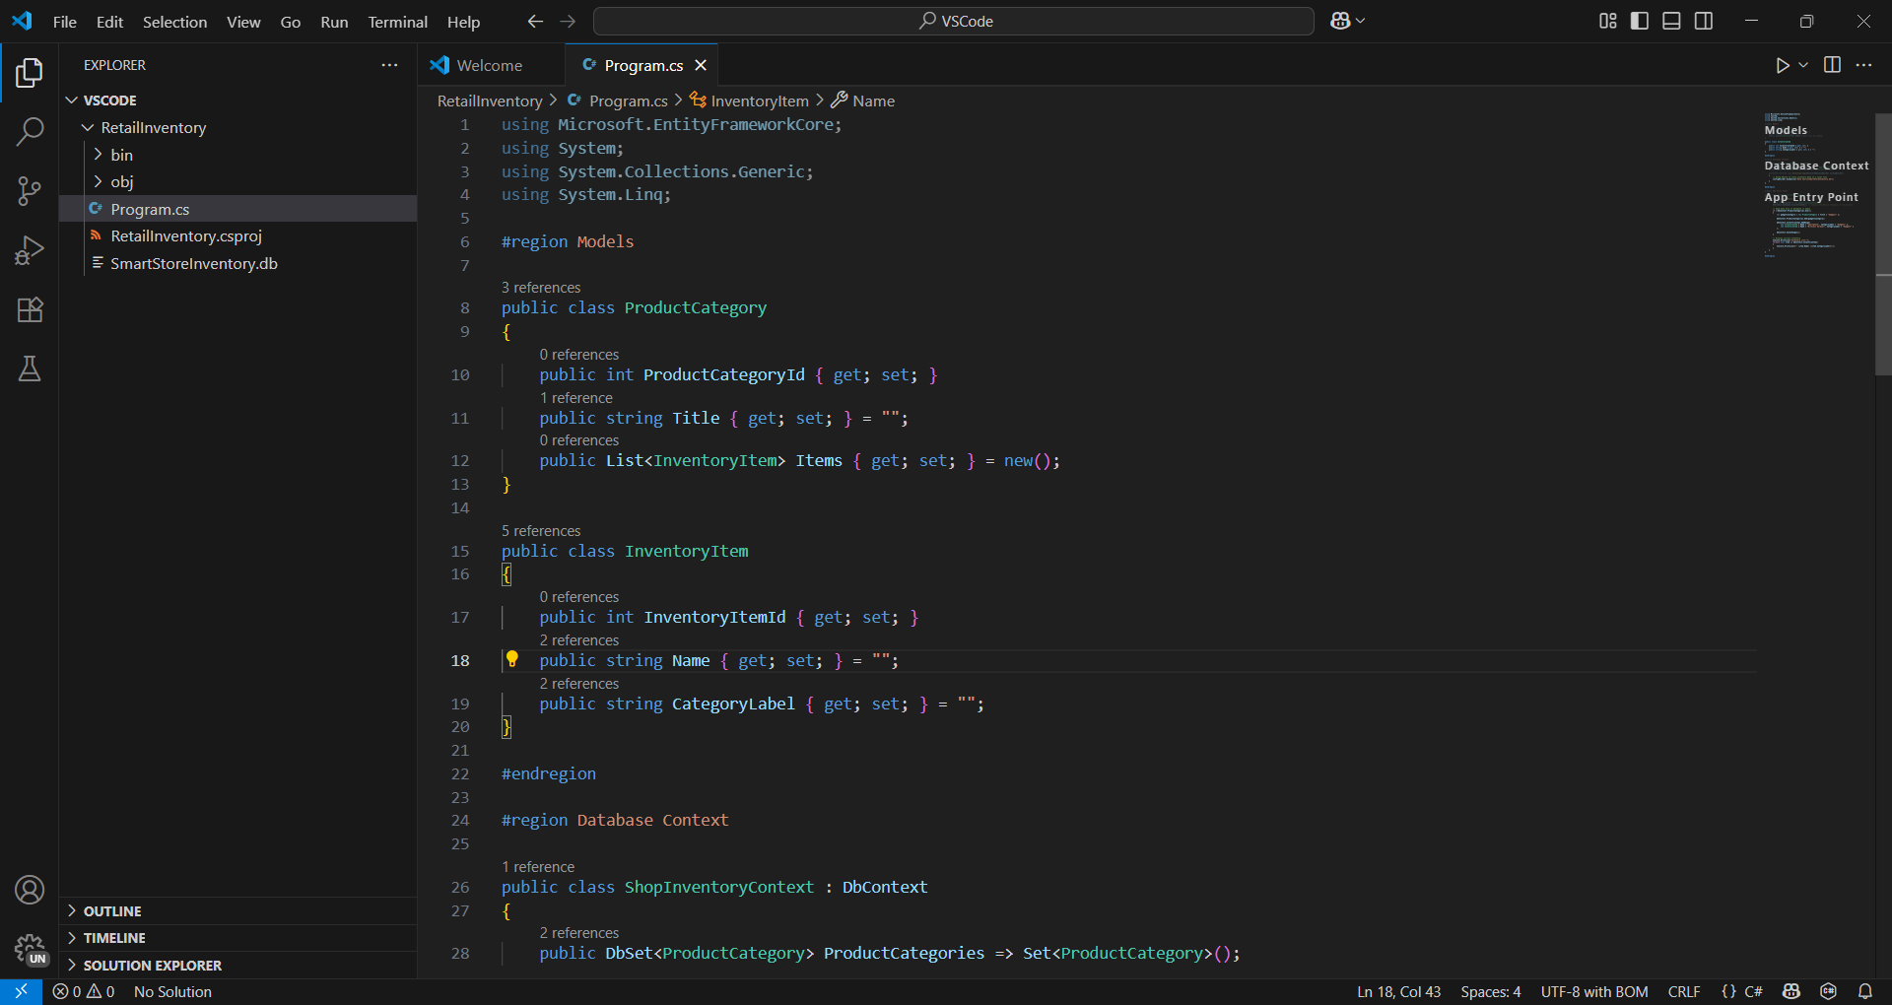ScreenShots:

